Datasheet

# Section 6: The Arena

## The Field

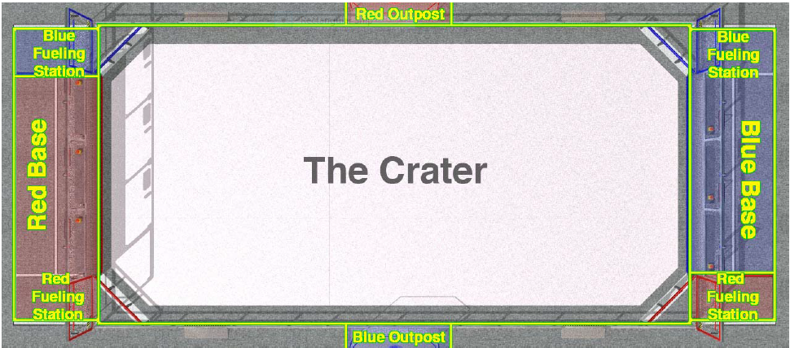

Size: 27 x 54 feet

Outputs Fueling Station

## Game Pieces



|  |  |  |
| --- | --- | --- |
| **Object** | **Color** | **Objects In the Arena** |
| Moon Rocks | Orange and purple | 120 |
| Empty Cells | Orange and Blue | Up to 8 (4 per alliance) |
| Super Cells | Green and purple | Up to 8 (4 per alliance) |

Each orbit ball is 9 inches in diameter.

## Payload Trailer

* Hexagonal base with an inscribed (face-to-face) diameter of 28 inches surrounded by bumpers.
* Twelve 1-5/16 inch OD plastic conduit pipes project vertically upwards in a 25-inch diameter circle. The heights vary, from 34 inches off the floor in the back to 42 inches in the front.
* A 4.2 inch diameter post projects vertically upward. The top is covered with a vision target
* The TRAILER is supported by two 6-inch diameter ROVER WHEELS.
* A TRAILER will be provided to you at the competition.

# Section 7: The Game

## Overview

* Matches are 2 min 15 seconds long.
  + Autonomous: 15 seconds.
  + Teleoperated: 2 minutes
* The score is determined by the number of GAME PIECES in the trailer once the MATCH has ended. If a TRAILER tips over, the points scored for that TRAILER at the time it was tipped will be preserved for the remainder of the match.
* You can use SUPER CELLS only during the last 20 seconds of the match.

## Starting configurations



## Handling Game Pieces

* PAYLOAD SPECIALISTS can enter MOON ROCKS into play by…
  + Launching then over the Alliance Station Wall
  + Launching them over/through the OUTPOST SHIELD
  + Using the provided tongs to pass them backwards through the FUELING PORT/AIRLOCK.
  + They cannot be thrown around the end of the Alliance Station Wall
* MOON ROCKS can only be recycled by passing them over/through the AIRLOCK and through the FUELING PORT, or by passing them through the port in the OUTPOST SHIELD.
* EMPTY CELLS must be passed through the port in the OUTPOST shield. They cannot be thrown.
* The OUTPOST has several EMPTY CELLS. A robot can take an EMPTY CELL to a FUELING STATION where it can be exchanged for a SUPER CELL. You can use a SUPER CELL during only the last 20 seconds of the match.
* Once a GAME PIECE has been scored, it cannot be intentionally removed from the TRAILER. GAME PIECES that accidentally fall off are fine.

## Robot Actions

* Robots may push or react against any elements in the ARENA, so long as there is no damage. Robots may not grab, grasp, grapple, or attach to any ARENA structure (apart from the TRAILER).
* High speed accidental collisions are normal and expected. Contact within the BUMPER ZONE is generally acceptable, but aggressive or intentional contact outside the BUMPER ZONE is not.
* You cannot intentionally try to tip a robot or trailer.

# The Robot

Unless otherwise noted, all standard robot rules apply (see rulebook). This paper will list only unusual rules that differ from the 2012 rules, or are in some way important

## Rover wheels

* Robots **must** use ROVER WHEELS (found in the Kit of Parts).
* Any number of ROVER WHEELS may be used.
* No other forms of traction devices (wheels, tracks, legs, etc) are permitted.
* The surface tread of the ROVER WHEELS may not be modified (no cleats, studs, carvings, etc. are allowed).

## Bumpers

* Bumpers must be a minimum of 6 inches long.
* A bumper must be between 1 and 7 inches off the ground.
* 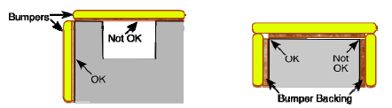Bumpers must use a stacked pair of 2.5 inch “pool noodles” as the bumper materials (bumpers are about 5 inches tall)

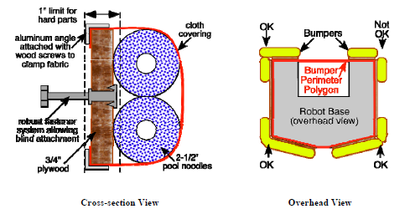

## Robot Dimensions and Constraints

* The maximum size of the robot is 28 x 38 inches. The max height is 60 inches.
* The maximum weight is 120 pounds
* The dimensions and weight excludes the battery, bumper assemblies, and the TRAILER.
* The school name, primary sponsor must be displayed on the robot.
* At the start of the match, the robot cannot exceed the dimensions specified above, and no part of the robot can extend beyond the BUMPER PERIMETER. (all arms, extensions, etc. have to be tucked away at the start of the match).

## The Trailer



* The Trailer Spacer is a 7-inch length of square steel tubing.
* The Trailer Mount Bar is a 7-inch length of robot chassis material
* The Trailer Hitch must be rigidly attached to the robot. The horizontal center line of the Trailer Hitch must be 2-13/16 inches above the floor (+/- 0.25 inches)

## Parts Allowed/Constraints

* A maximum of four 2-1/2” CIM motors may be used.
* The CAN bus ports on the Jaguars are prohibited for this competition.
* Pneumatics
  + All pneumatics must be rated for pressure of at least 125psi
  + A maximum of four Clippard air storage tanks may be used on the robot
  + The “working” air pressure on the robot must be no greater then 60psi